**Chapter No: 1**

**INTRODUCTION**



**Chapter No:**

**Literature Review**



**Chapter No-3**

**NEED OF WORK**



**Chapter V**

**PLAN OF WORK**



**Chapter No VI**

**PLANT PROFILE**

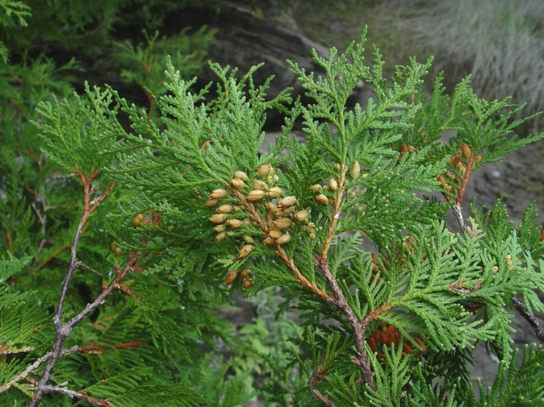

**REFERENCE**



**Chapter No VIII**

**RESULT & DISCUSSION**

